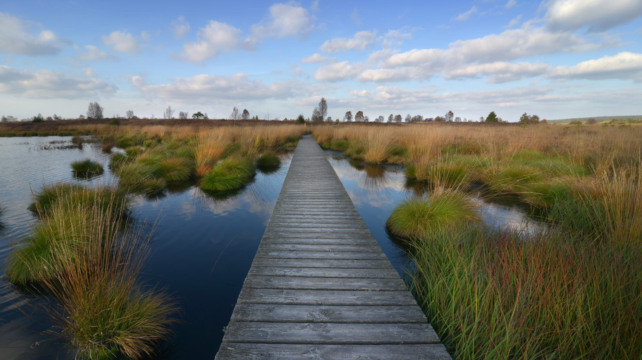P.E.D.R.O. Manual

Peatland Equipment data re-organizer

Table of Contents

setup 4

JAVA 4

Windows 4

windows security 5

Mac 6

Computer Architecture 6

Setup commands 8

PEDRO 10

FMA 10

Required files 11

Sample data file **(.csv or .txt)** 11

FMA data file **(.csv or .txt)** 11

Methodology 11

output 12

LICOR (Fluxes) 12

required files 13

Field data file **(.csv or .txt)** 13

LICOR file **(.csv or .txt)** 13

Methodology 14

output 15

Summary sheet 15

Collar sheets 15

LICOR (Samples) 16

Required Files 17

Sample data file **(.csv or .txt)** 17

LICOR file **(.csv or .txt)** 17

Methodology 17

output 18

LGR (Fluxes) 18

required files 19

Field data file **(.csv or .txt)** 19

LGR file **(.csv or .txt)** 19

methodology 19

output 19

LGR (Samples) 19

required files 20

Sample data file **(.csv or .txt)** 20

LGR file **(.csv or .txt)** 20

methodology 20

output 20

IRGA (EGM-5 only) 20

required files 21

Field data file **(.csv or .txt)** 21

Flux files **(.txt)** 21

methodology 22

output 22

GC 22

required files 22

naming regex 24

Examples 24

methodology 25

output 26

Standards sheet 26

Date sheets 26

Source code 27

Support 27

Acknowledgements 27

# setup

## JAVA

To begin, you must install Java on your computer for PEDRO to function properly. You can find the appropriate version of Java for your computer at this [website](https://java.com/en/) by clicking on the *downloads* button.

## Windows

If you’re using a windows PC, the appropriate file can be found on the Wetland Soils and GHG Exchange lab Microsoft Teams in the general channel under the folder ‘*PEDRO data analysis tool’*. Download the file ‘*PEDRO.exe’,* found In the ‘*Windows*’ folder as shown below. This is the only required file for PEDRO to run on a windows PC, it can be saved anywhere on your computer.

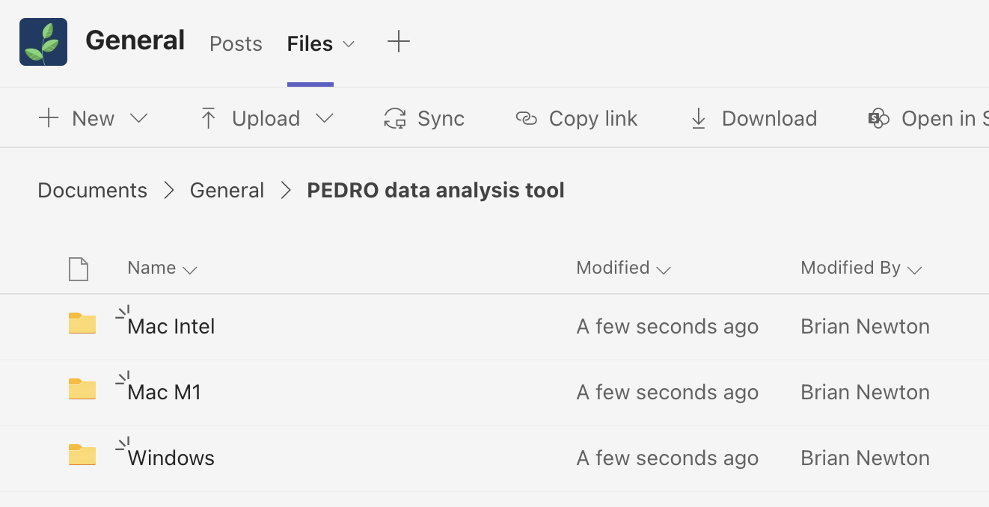

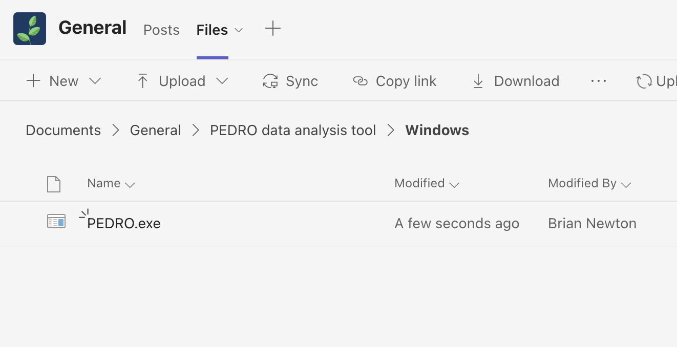

### windows security

When you first run the downloaded application, it’s very likely you’ll get the following message from windows defender and the app won’t start.

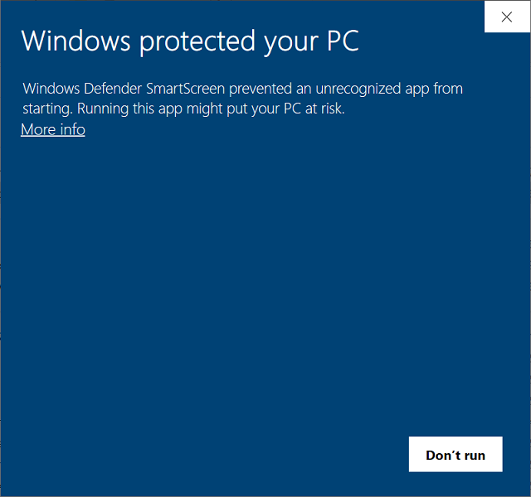

This is because this application is ‘unsigned’ by a certified developer. Unfortunately, code certifications are very expensive so the app will have to be manually excluded from this security block. **This software poses absolutely no security risk to your computer, if you want to be certain you can browse the source code** [**here**](https://github.com/BrianNewton/PEDRO)**.** To disable this security block, you’ll have to add an exception for the downloaded file. This can be done with the following steps:

1. Go to *Start > Settings > Update & Security > Windows Security > Virus & Threat Protection*
2. Under *Virus & Threat Protection* settings, select *Manage Settings*, and then under *Exclusions,* select *Add or Remove Exclusions*
3. Select *Add an exclusion* and then select the downloaded *PEDRO.exe* file.

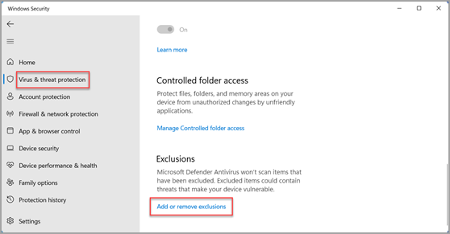

After these steps have been completed, try running the application again.

## Mac

### Computer Architecture

Before downloading any files, you must first determine whether your Mac has an Apple M1 or an intel processor. This can be done by selecting the Apple logo at the top left of your status bar and selecting *About this Mac*. If your Mac has an M1 chip it will say ‘Chip Apple M1`, if your Mac has an intel processor it will say *‘Processor […] intel Core […]’*.

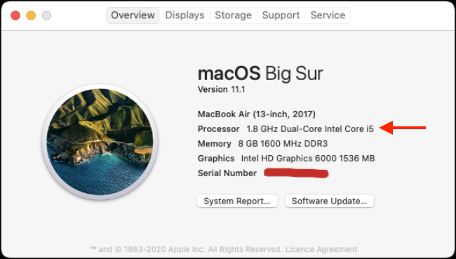

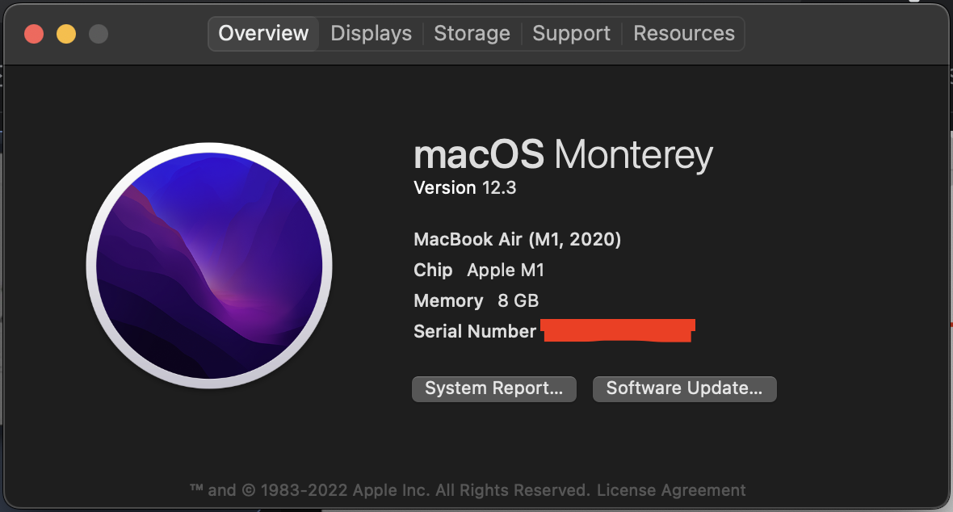

Once this has been determined, download the correct version of the software for your computer. In the general channel of the Wetlands Soils and GHG Exchange Lab’s Microsoft Teams, there’s a folder called ‘*PEDRO data analysis tool’,* inside this folder there is an option for ‘*Mac Intel’* and *‘Mac M1’*, select the appropriate one for your computers architecture and download the zip folder ‘*PEDRO.zip’* contained within. Shown below is ‘*Mac M1’* as an example. **Extract the .zip folder to your Desktop, as shown below.**

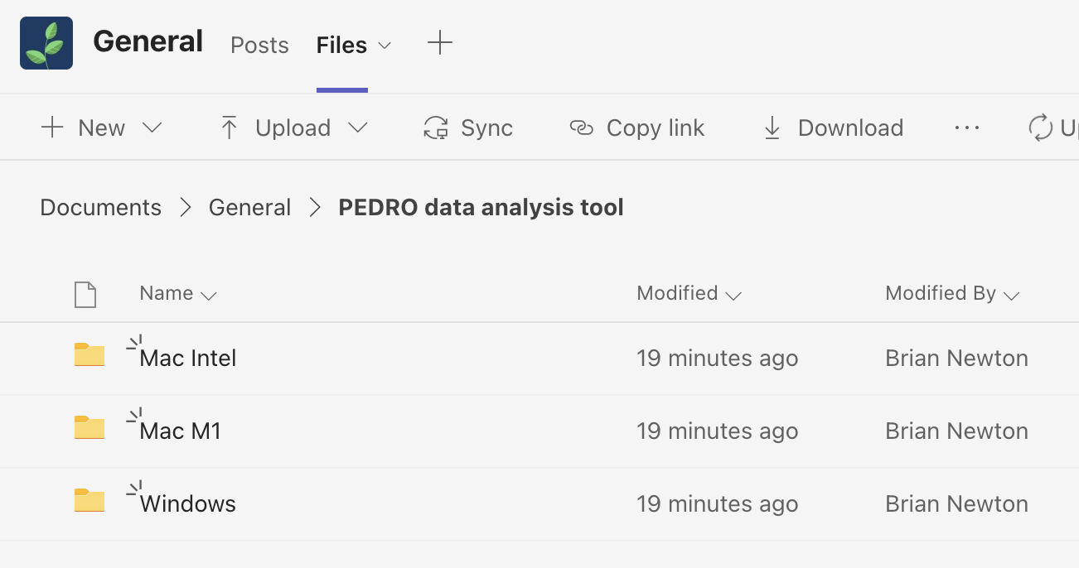

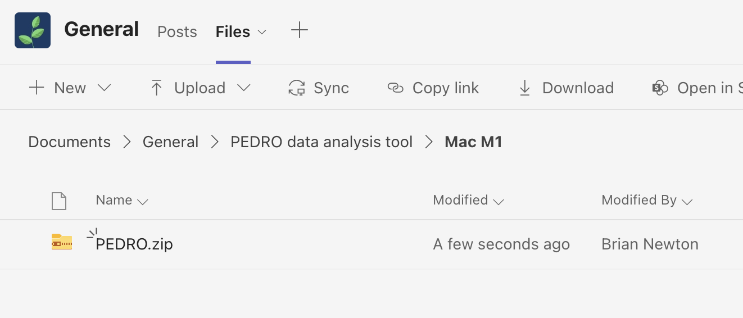



### Setup commands

Once the correct folder has been downloaded, the application needs to be setup for execution through a terminal session. To open a new terminal, select the launchpad icon  In the dock and type ‘*Terminal’* in the search field, then click *Terminal*.

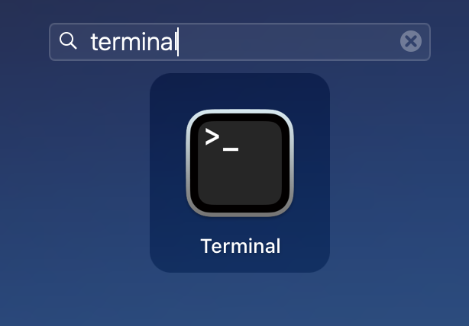

Once the terminal session has been opened, the following commands must be executed in the correct order for the application to run (these commands are case sensitive!):

> cd Desktop/PEDRO

The above command navigates the terminal session to the folder where the application is saved.

> chmod +x PEDRO

The above command indicates to the computer that the file ‘*PEDRO’* is meant to be executable on its own and not by a third-party app.

> sudo xattr -d -r com.apple.quarantine *

The above command indicates to the computer that the downloaded files are not a security threat and allows them to be executed without issue. You’ll be required to enter your password after submitting this command. The reason why this is necessary is that the application is ‘unsigned’ by a certified developer, since unfortunately code certifications are very expensive. **This software poses absolutely no security risk to your computer, if you want to be certain you can browse the source code** [**here**](https://github.com/BrianNewton/PEDRO)**.**

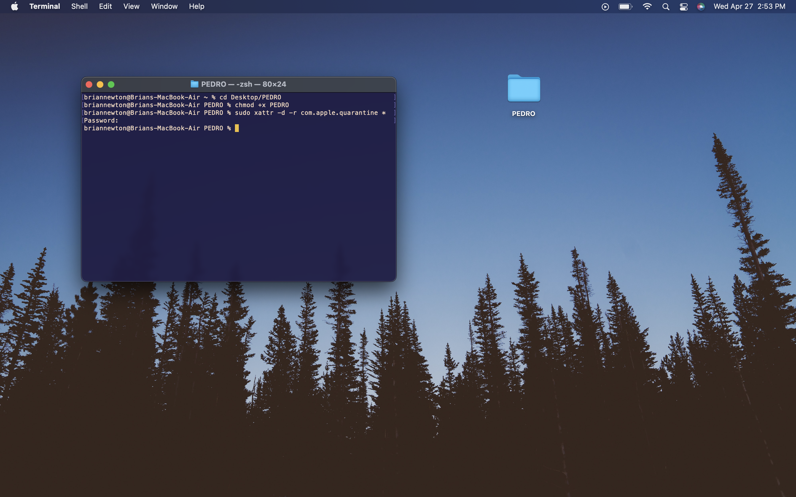

After these commands have been entered, you can close the opened terminal. The application can now be launched by double clicking the file ‘*PEDRO’* located inside the folder ‘*PEDRO’ on your desktop*.

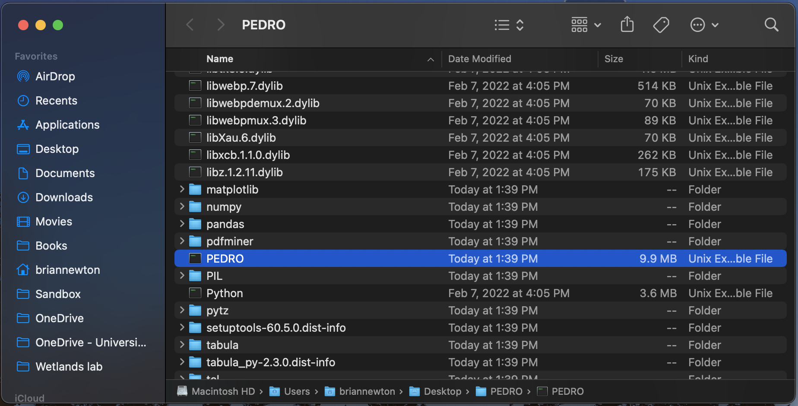

For ease of use, it’s recommended to create an alias to this file by right clicking ‘*PEDRO’* and selecting *Make Alias*. After creating this alias, you can move it to your desktop and move the folder *‘PEDRO’* somewhere out of the way on your computer.

# PEDRO

Once you’ve completed the setup procedure for your computer, you should be able to launch the application. Running the application will open another terminal window that provides some background information as you’re using the app. **This terminal window can be safely minimized but closing it will also close the PEDRO app.** Once the app opens, you’ll see the main menu with navigation buttons for each available option.

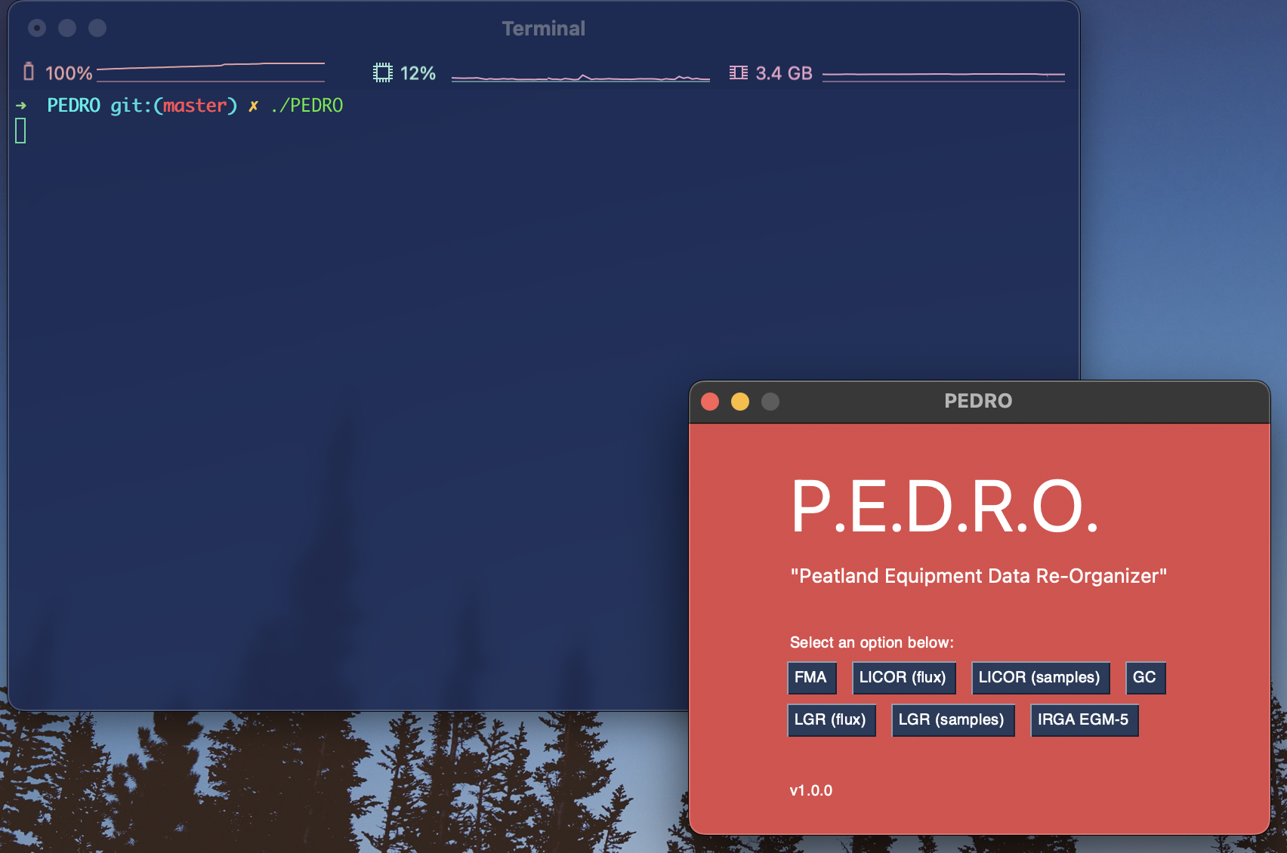

# FMA

The FMA package quickly and easily calculates sample CH4 concentrations using the output from the *LGR Fast Methane Analyzer.*

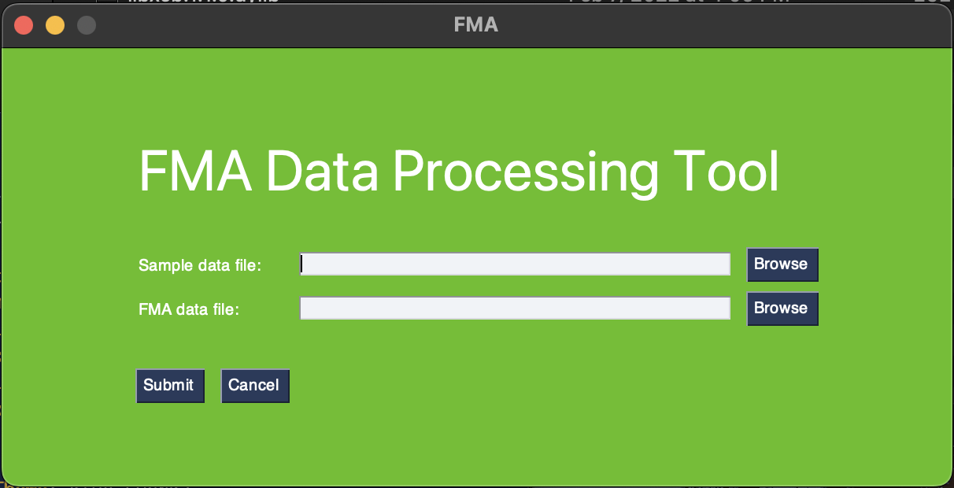

## Required files

The FMA data processing tool requires two files, a sample data file which records the times that each sample was injected and the FMA data file which is obtained from the machine itself. These two files must be selected within the FMA data processing tool to continue.

### Sample data file **(.csv or .txt)**

The sample data file is created by you! This file records the injection times for each sample or standard into the FMA, these times are displayed on the FMA itself as you run samples. This file is formatted by having one line per sample/standard that includes the samples name followed by a comma and followed again by the injection time. There’s an example file in the ‘*Sample-files’* folder in the ‘*PEDRO data analysis tool’* folder on the Wetland Soils and GHG Exchange Lab Microsoft Teams. An example of formatting is shown below.

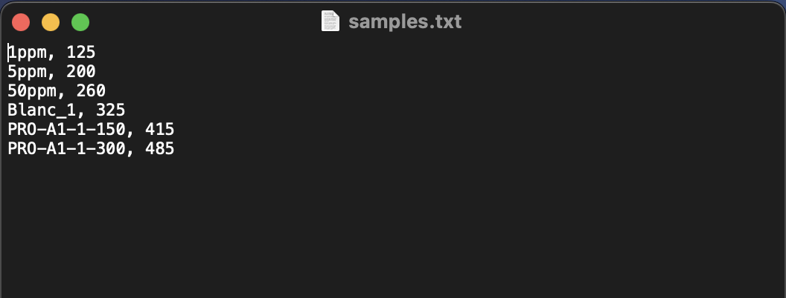

### FMA data file **(.csv or .txt)**

The other required file is the FMA data file obtained from the FMA itself. This file can be obtained onto a USB key from the FMA file transfer menu. Don’t make any changes to the FMA file.

## Methodology

Once the two files have been selected, click submit to begin data processing. For each sample in the samples data file, the tool will pull the corresponding data from the FMA file and present it to you in a graph. Each injected sample will have a peak in CH4 concentration associated with it. To get precise concentration measurements, you must indicate to the script where the peak occurs for each sample by dragging the two red cursors around the boundaries of the sample peak. Once this has been done for the current sample, use the arrow keys on your keyboard to navigate to the next sample. Below is shown a sample before and after peak selection.

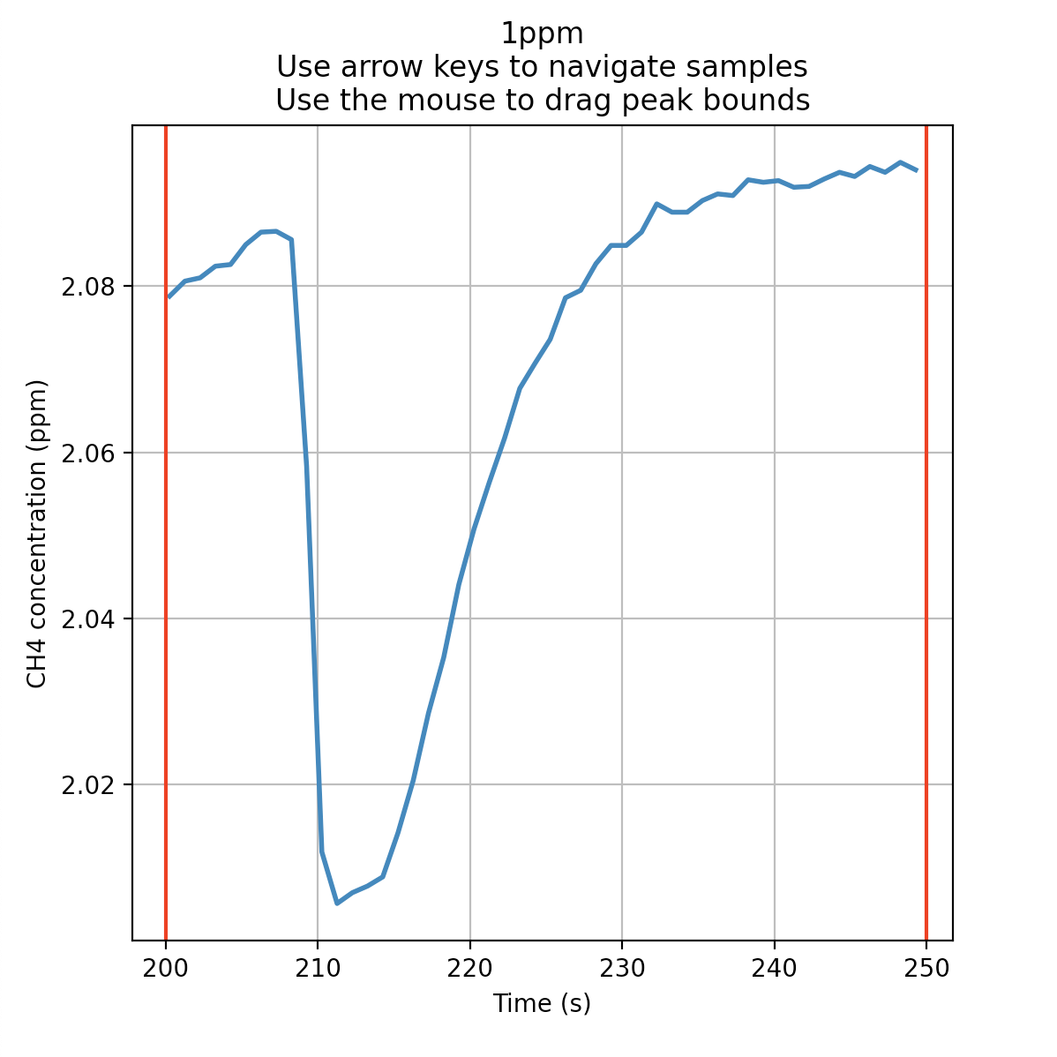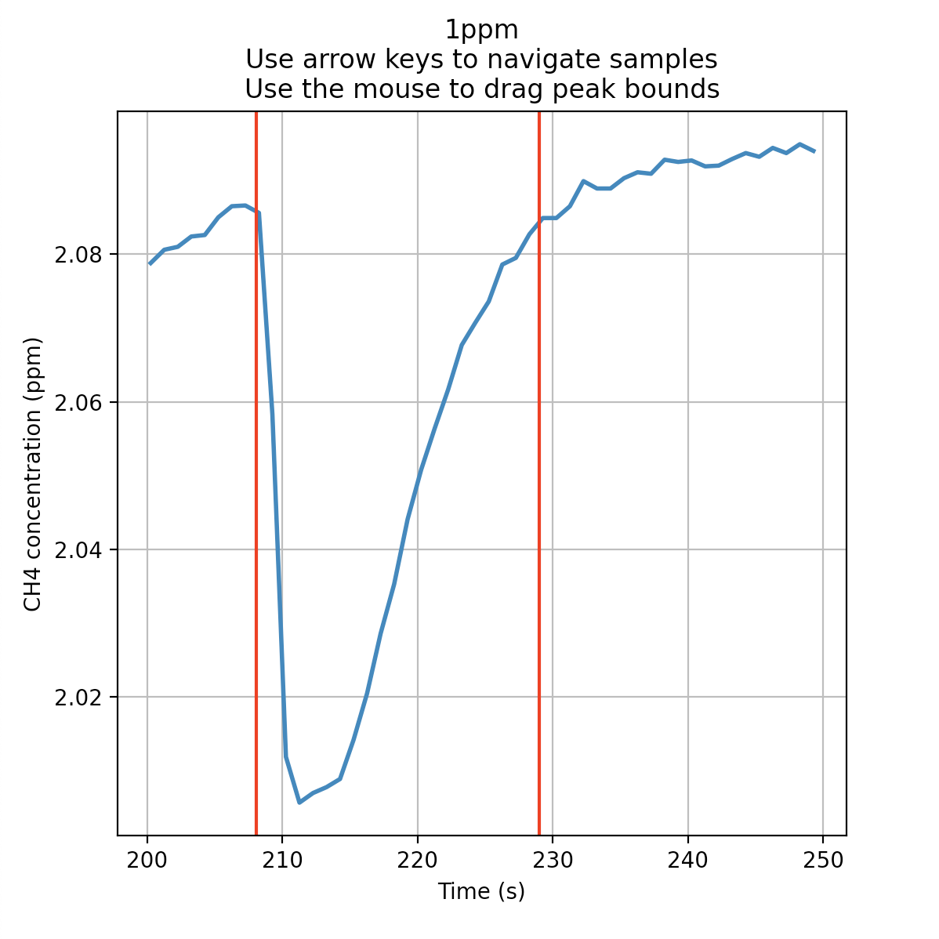

The data analysis tool uses methane standards (1ppm, 5ppm, or 50ppm) to generate a linear relationship between peak area and CH4 concentrations. To maximize the accuracy of the model, it’s recommended to use one of each standard after every 12-16 samples.

## output

After the last sample has been processed, the tool will prompt you to select a location and name for the output excel spreadsheet. At the top of the sheet is a field to fill in either the date the samples were run on the FMA or the date the samples were taken. Beneath that are the generated parameters for the linear model used to calculate CH4 concentrations. If the standards for a given run were contaminated, these parameters can be changed, and the change will be reflected in the spreadsheet CH4 concentrations.

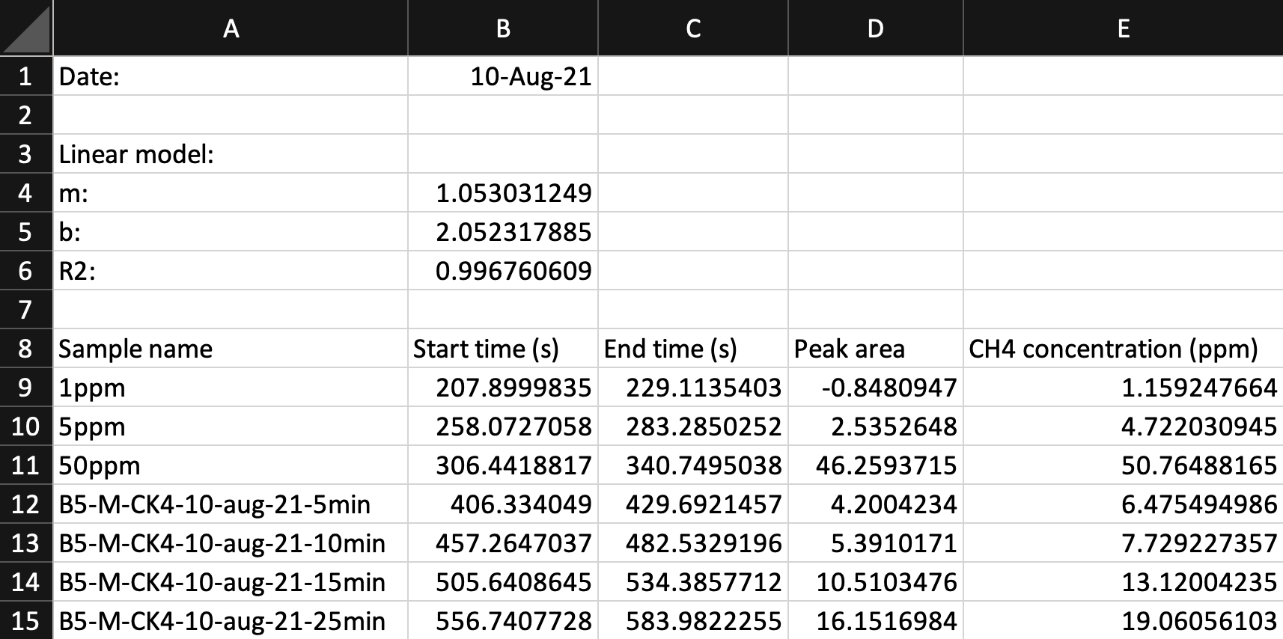

# LICOR (Fluxes)

The LICOR (flux) package extracts and analyzes the raw data outputted by the LICOR gas analyzer. The tool requires a field data file and a LICOR data file. The tool can only analyze one gas at a time which must be selected along with filling in the site name and flux dates.

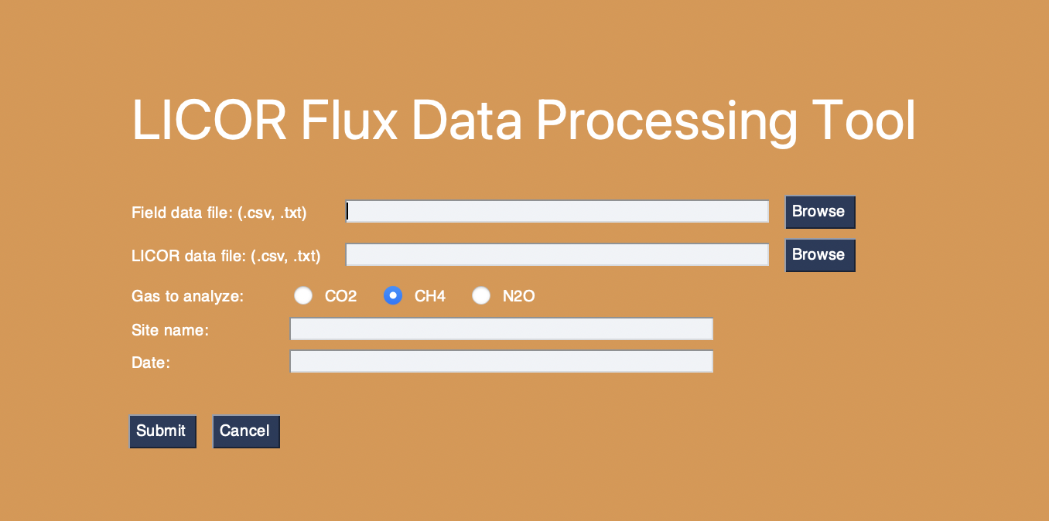

## required files

The LICOR data processing tool requires two files, a field data file which tracks information about each flux collar and the raw LICOR data file which is obtained from the machine itself. These two files must be selected within the LICOR data processing tool to continue.

### Field data file **(.csv or .txt)**

The field data file is created by you! It’s a file that records information about each flux collar. You must indicate the start and end times (in HH:MM:SS) indicated on the LICOR in the field while the machine was connected to the flux chamber, the start and end temperatures of the flux measurement, whether the chamber was light or dark, the internal height of the chamber and its surface area. A template file can be found in the ‘*Sample-files’* folder in the PEDRO GitHub.

Please ensure that your temperature, chamber height and surface area values are correct. The chamber height must be in units of meters. It will be used to calculate the gas headspace volume, and must thus include the height of the chamber, and the distance between the peat surface and the top of the collar, if applicable. The surface area heading refers to the surface area of the collar.

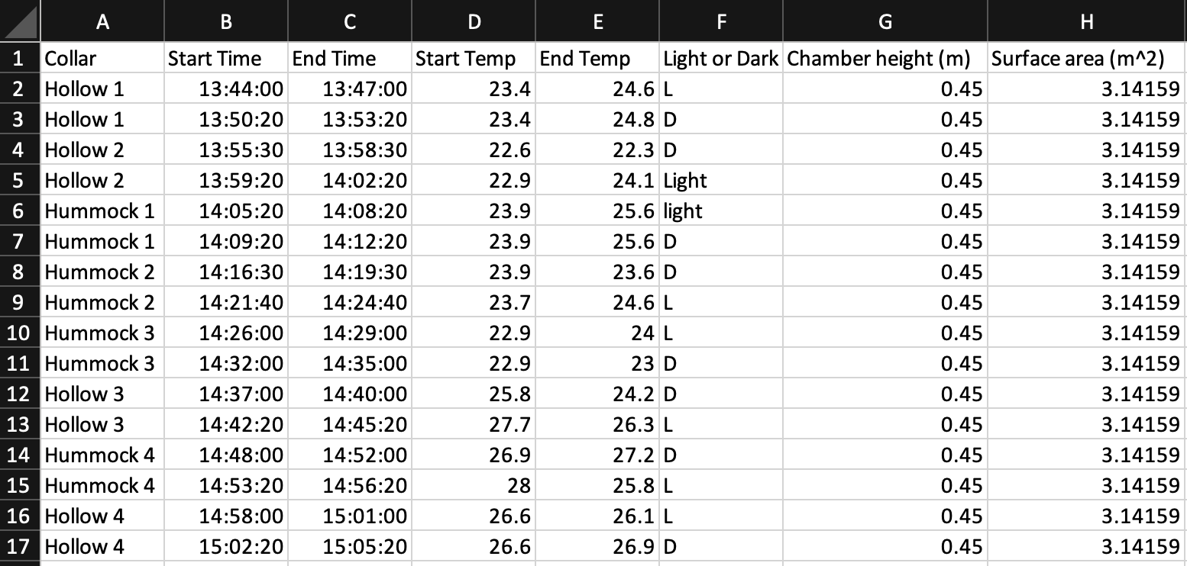

### LICOR file **(.csv or .txt)**

The other required file is the LICOR data file obtained from the LICOR gas analyzer itself. Don’t make any changes to the LICOR data file.

## Methodology

Once all the information has been entered. The tool uses the start and end times in the field data file to extract the fluxes from the LICOR data file. Each flux will be displayed in a graph for processing, where non-linear regions can be cut to make the flux calculations more accurate. To cut part of the flux, drag the cursors to surround the bad data and press enter to confirm the cut. If you’d like to revert the cuts, press r to reset all the original flux data. Shown below is a flux before and after the non-linear start has been cut.

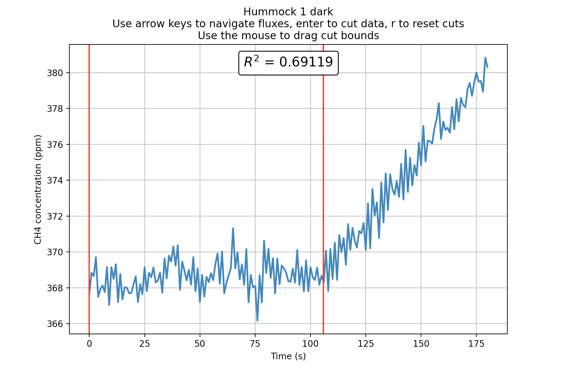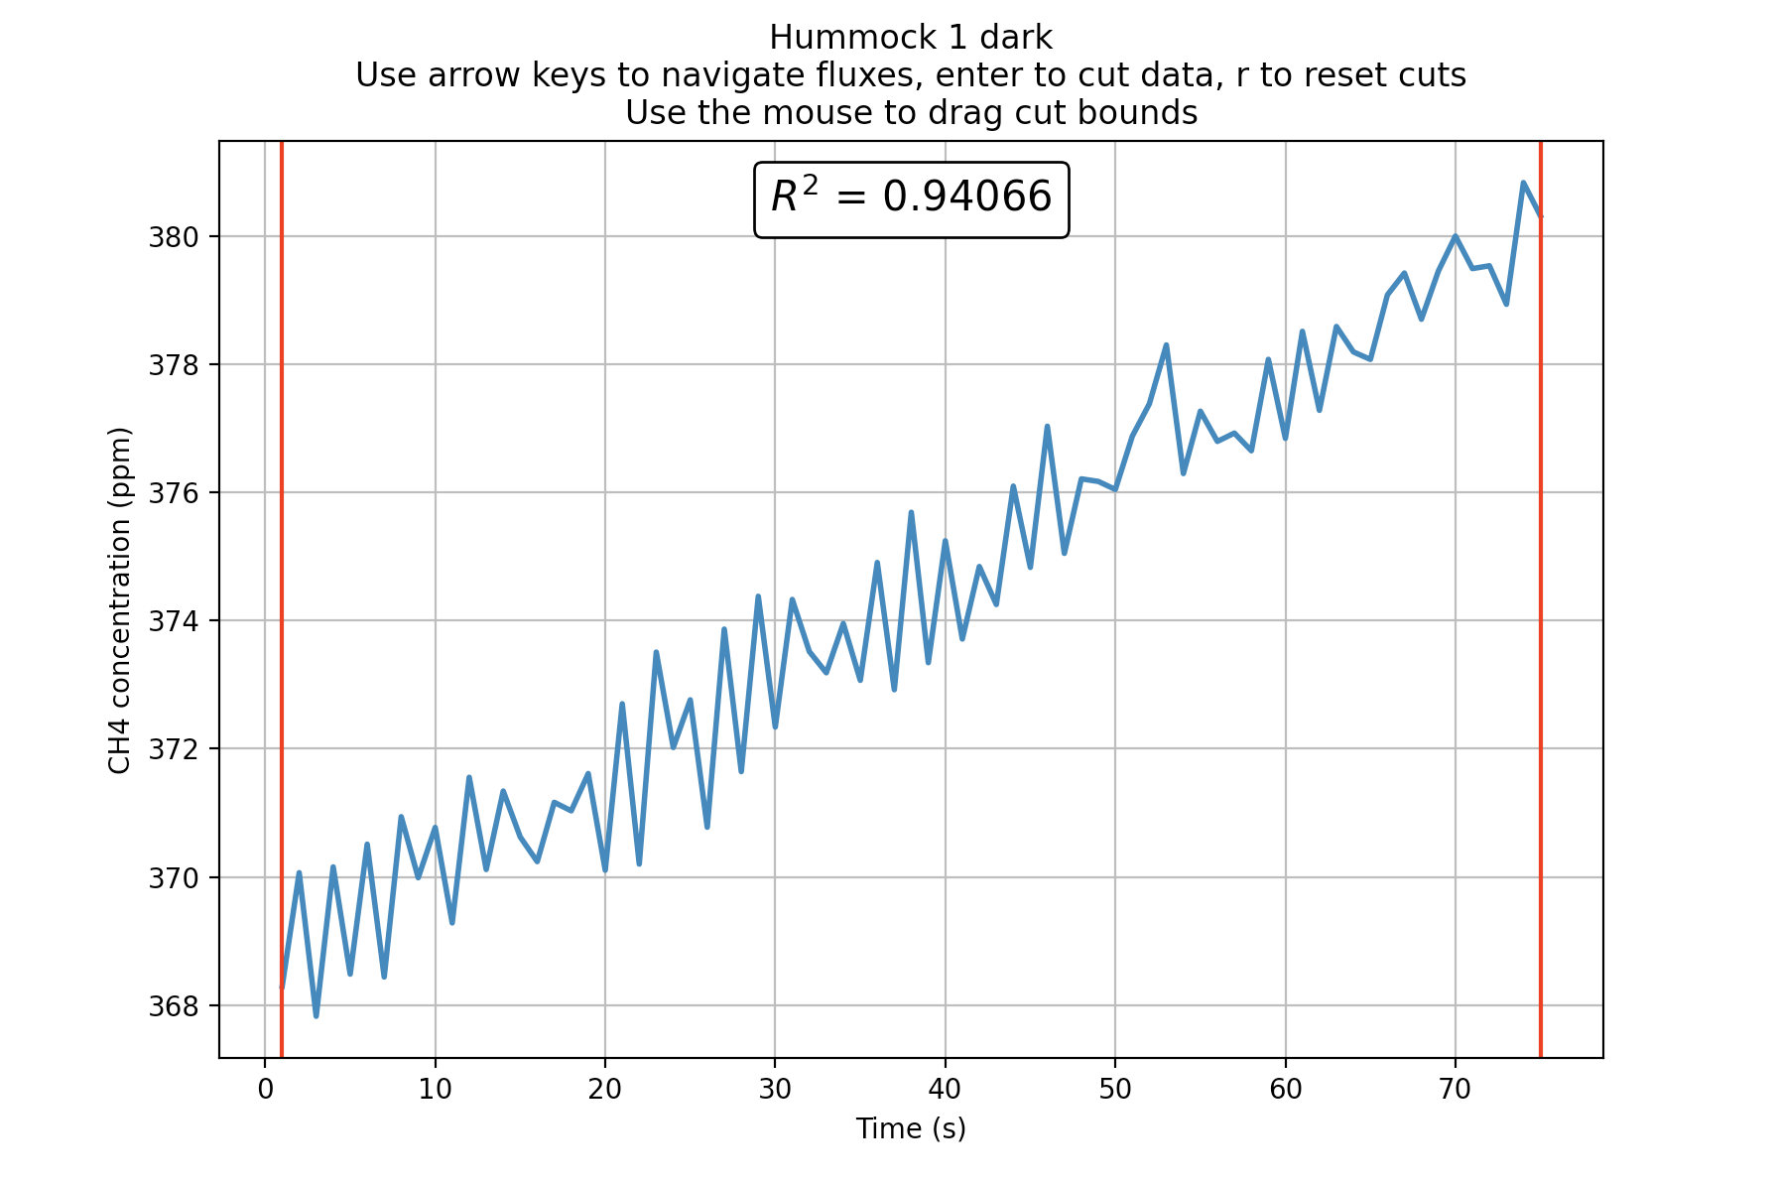

In addition to trimming the flux at the beginning and end, faulty data (from ebullition events for example) can also be pruned from the middle of the flux. All the data points after the cut will be offset by a constant concentration margin calculated as the difference between the last data point concentration before the cut and the first concentration after the cut. In addition, all data points after the cut are shifted ‘*back in time’* by the time width of the cut. This is in order to maintain the linearity of the two segments by connecting the two points immediately before and after the cut, pretending the cut region ‘*never happened’*. An example of data being pruned from the middle of the flux is shown below.

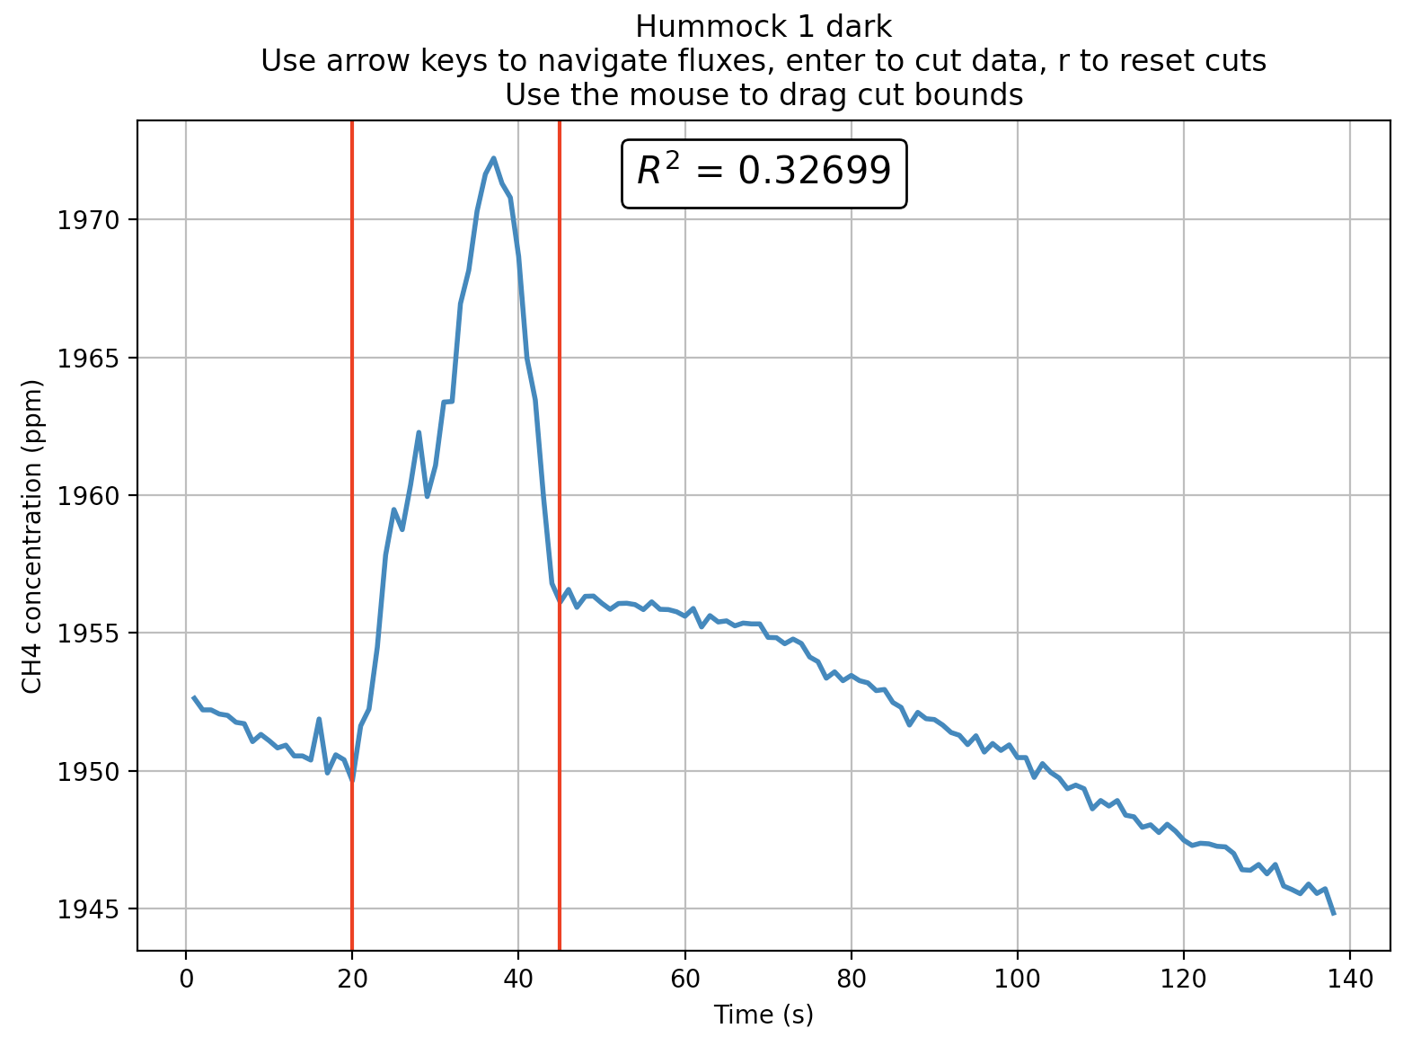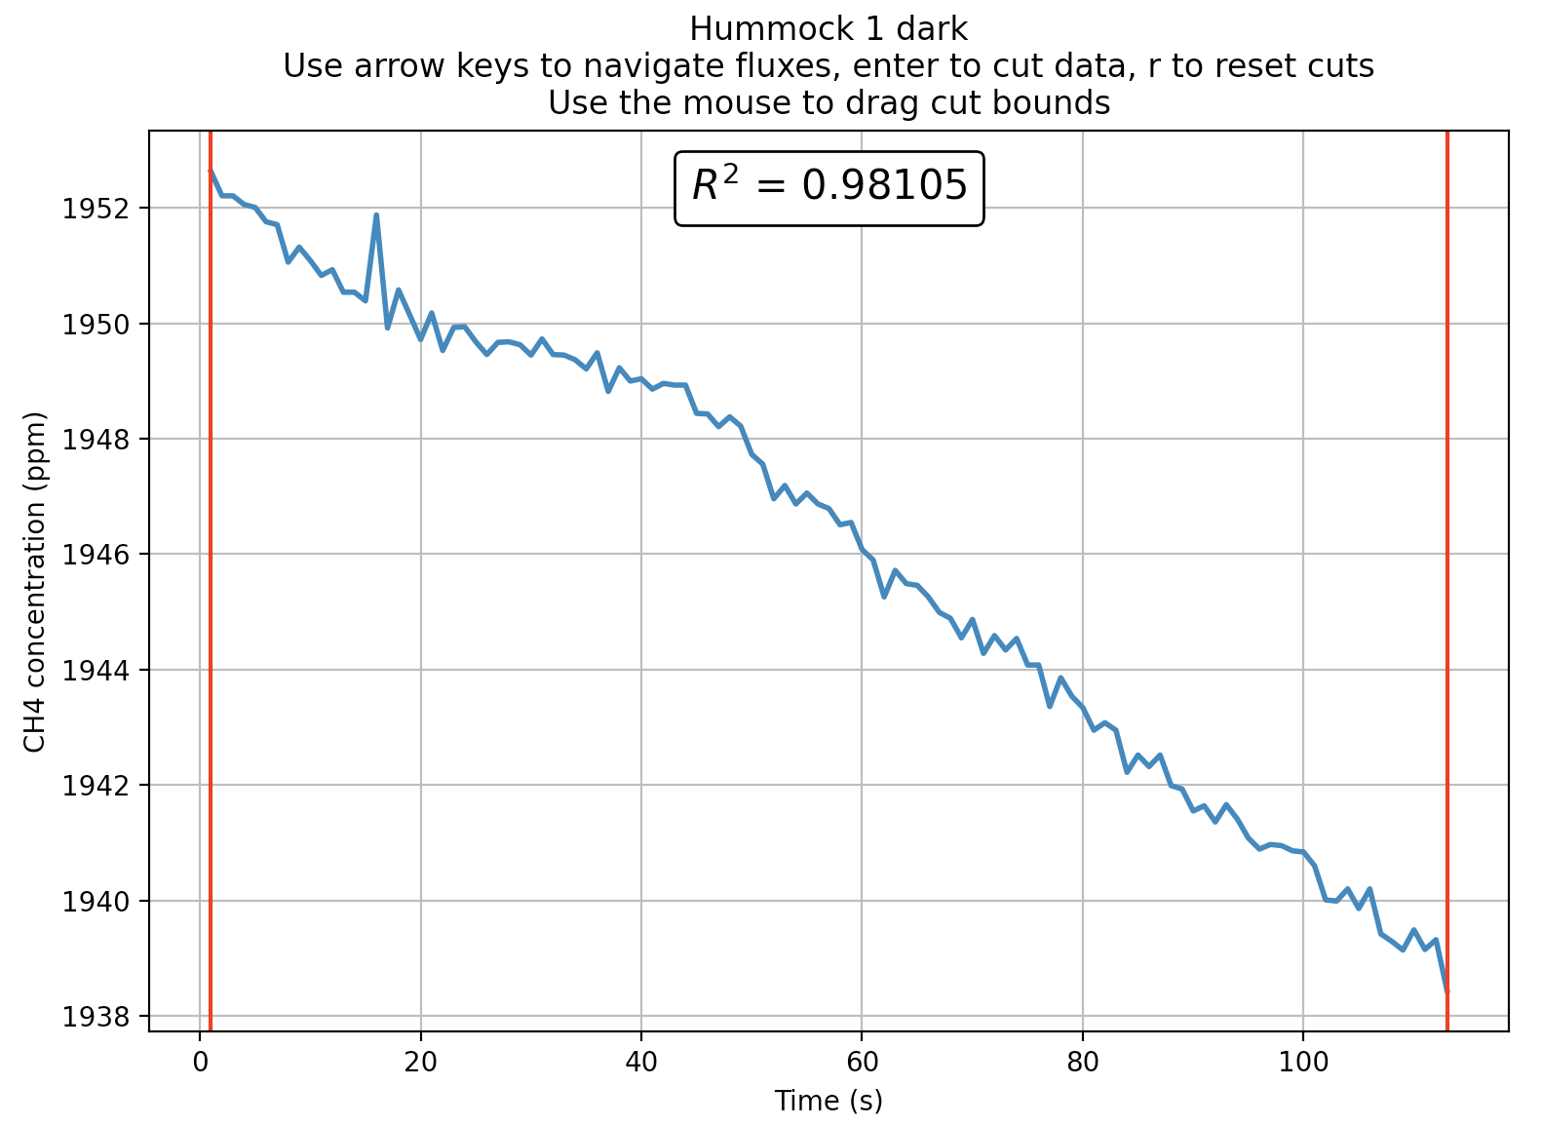

The methodology behind shifting the data around middle cuts is displayed more clearly in the following figure. It shows how concentration and time offsets are applied to preserve linearity.

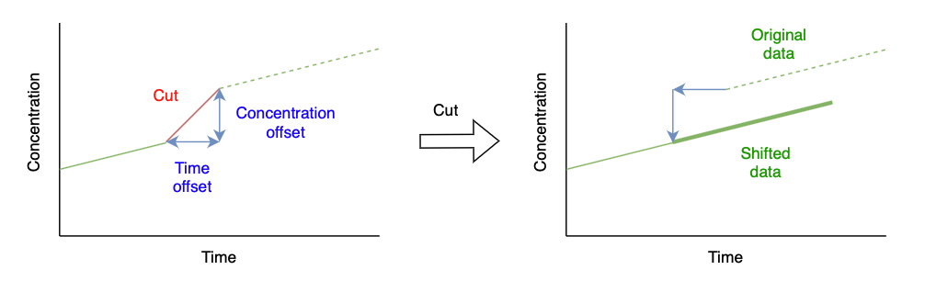

**It’s up to you how much you’d like to manipulate your data. If the methodology behind cuts in the middle of a flux is more than you’re comfortable with, limit your cuts to the ends of the data where no offsets are applied.**

The flux of your gas of interest (CO2: g C m-2 d-1; CH4: mg C m-2 d-1; N2O: mg N2O m-2 d-1) is calculated using the following equation, where fx is the rate of change of your gas of interest (in ppm/min for CO2, in ppb/min for CH4 and N2O), V is the chamber volume in L, R is the ideal gas constant (0.0821 L atm K-1 mol-1), T is the average chamber air temperature (K), n is the molecular mass of the gas of interest (CO2: 0.044 kg mol-1; CH4: 0.016 kg mol-1; N2O: kg mol-1), t is the number of minutes in a day (1400 min d-1) and S is the surface area of the chamber (m2). For CO2 and CH4 calculations, the flux is multiplied by 12/44 and 12/16 respectively to obtain an answer in units of C, and not CO2 or CH4. You can choose to use the rate of change provided in the output excel file, and perform the calculation yourself.

$$Flux= \frac{f_{x}×(\frac{V}{R×T})×n×t}{S×1000}$$

## output

Once you’ve finished processing the last flux collar in the field data file, the tool will prompt you to select a location and name for the output excel spreadsheet.

### Summary sheet

The first page of the output spreadsheet will contain a summary of each collar, including chamber volume, temperature and flux data calculated by a linear regression. The ‘*Data loss (%)’* metric represents how much data was lost in cuts. It also generates some empty row headings for additional data to be filled in by you if you choose.

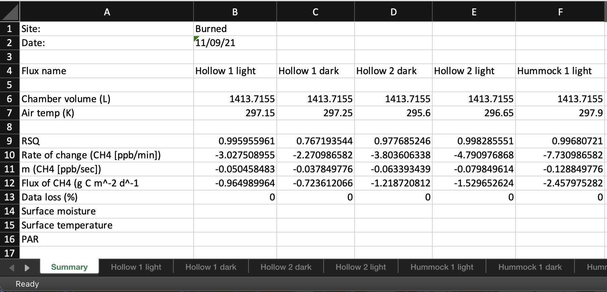

### Collar sheets

In addition to the summary sheet, a sheet will be created for each individual collar showing more in-depth information. These sheets will show all the original data taken from the LICOR output file as well as any changes that were made with cuts. These changes are represented by the columns ‘*Pruned times (s)’, ‘Time offsets (s)’, ‘Pruned […] concentrations (ppb)’* and *‘[…] concentration offsets (ppb)’*. The ‘*Offset*’ columns indicates whether an offset has been applied to that row’s data point and its value (0 means no offset). The ‘*Pruned’* columns show the final data used to calculate a linear flux after the cut offsets have been applied. If a data point from the *‘Original’* column has been cut, it’s corresponding row in the *‘Pruned’* column will be empty. If no cuts have been made, the ‘*Pruned’* columns and the ‘*Original’* will be identical and the ‘*Offsets*’ will be all zeroes.

A graph will also be displayed showing which data has been cut and which has been preserved. This graph will also show any applied concentration offsets. An example of the reported pruned data and offsets as well as the graph displaying this information is shown below.

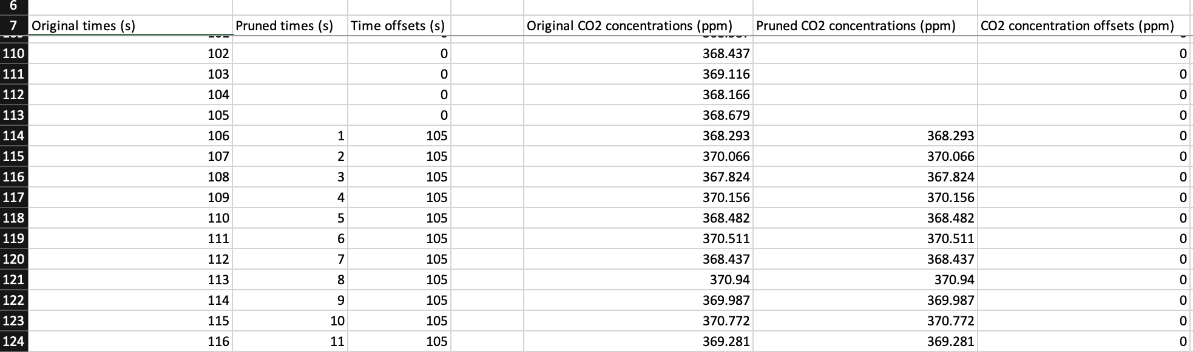

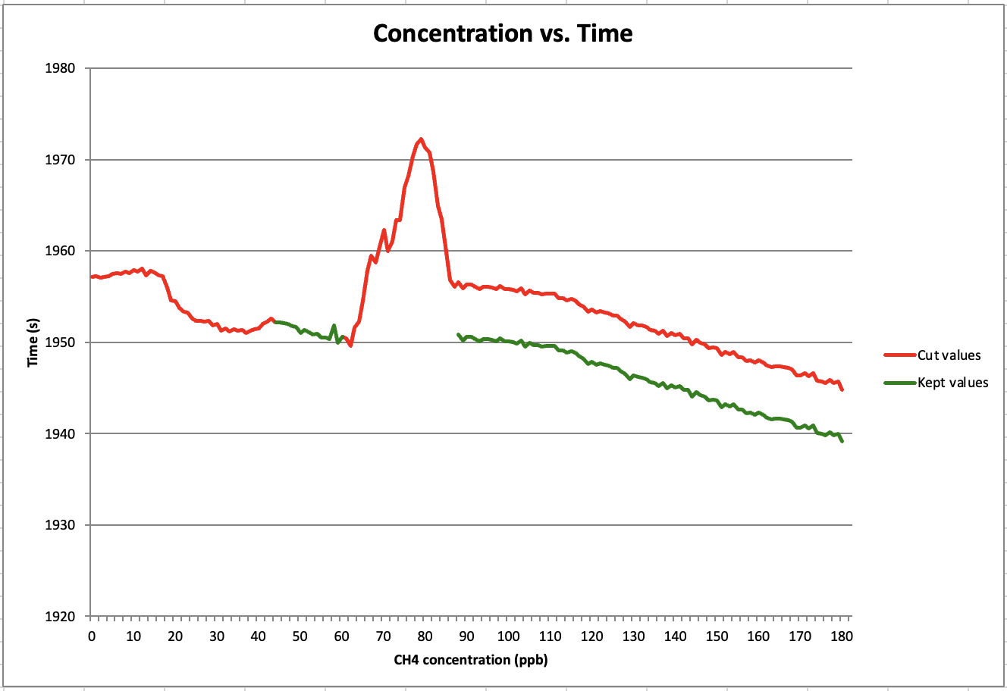

# LICOR (Samples)

The LICOR (samples) package functions similarly to the FMA package. It first calculates a sample concentration in ppm (using the area under the curve method) of your gas of interest (CO2, CH4 or N2O) from your injected samples. It then generates a linear regression between the peak areas of your injected standards, and their known concentrations (in units of ppm) using the statsmodels.api package in Python. Finally, it uses this regression to correct the gas concentrations of your samples.

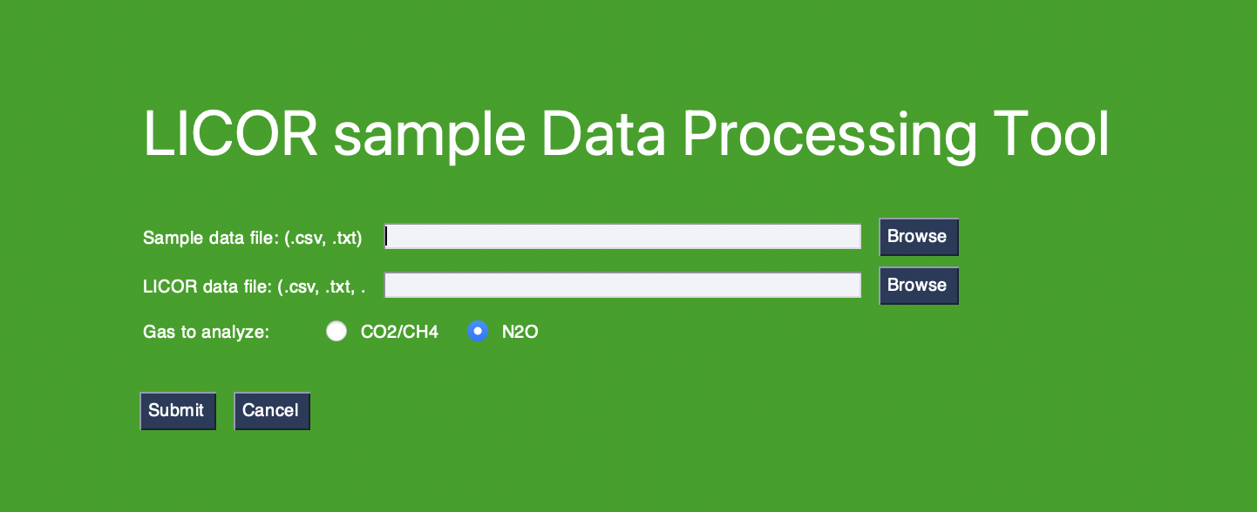

## Required Files

### Sample data file **(.csv or .txt)**

The sample data file is created by you! This file records the injection times for each sample or standard into the LICOR. This file is formatted by having one line per sample/standard that includes the sample name followed by a comma and followed again by the injection time. PEDRO has been built to recognize 4 standard gas mixtures (see table below). If you have standards with different concentrations, you will need to edit these values on lines 382 to 420 in Licor_Samples.py.

|  |  |  |  |
| --- | --- | --- | --- |
|  | CH4 concentration (ppm) | CO2 concentration | N2O concentration |
| Standard 1 | 1 | 307 | 0.0890 |
| Standard 2 | 5 | 100 | 1 |
| Standard 3 | 50 | 497 | 2 |
| Standard 4 | 1000 | 5008 | n.a. |

In your sample data file, please refer to the standards by their CH4 concentrations ( 1 ppm, 5 ppm, 50 ppm or 1000 ppm), even if you are interested in analysis for CO2 or N2O gases.

There’s an example file in the ‘*Sample-files’* folder on the PEDRO GitHub. An example of formatting is shown below.



### LICOR file **(.csv or .txt)**

The other required file is the LICOR data file obtained from the LICOR gas analyzer itself. Don’t make any changes to the LICOR data file.

## Methodology

Click on browse to find input your sample data file and licor file, choose your gas of interest for analysis, and then click submit to begin data processing. For each sample in the samples data file, the tool will pull the corresponding data from the LICOR file and present it to you in a graph. To get precise concentration measurements, you must indicate to the script where the peak occurs for each sample by dragging the two red cursors around the boundaries of the sample peak. Once this has been done for the current sample, use the arrow keys on your keyboard to navigate to the next sample. Below is shown a sample before and after peak selection. The LI-7810 trace gas analyzer also measures H2O concentration, and we have included a plot of these concentrations to aid in peak selection.



When you select the CO2/CH4 gas button, you will see plots of CH4, CO2 and H2O concentrations. Your peak area selection on the CH4 will be applied to the CO2 data.

To maximize the accuracy of the model, it’s recommended to run standards after every 12-16 samples.

## output

After the last sample has been processed, the tool will prompt you to select a location and name for the output excel spreadsheet. At the top of the sheet is a field to fill in either the date the samples were run on the LICOR or the date the samples were taken. Beneath that are the generated parameters for the linear model used to calculate CH4, CO2 or N2O concentrations. We have included the m and b parameters of the linear regression, along with the associated F-statistic and p-value of the model.

# LGR (Fluxes)

The LGR (flux) package analyzes the output from a LGR gas analyzer and uses information passed through a field file to calculate gas fluxes.

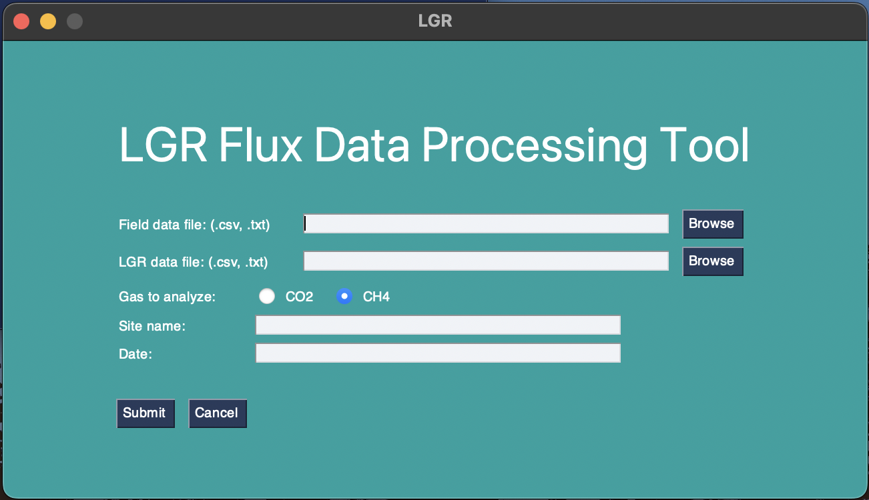

## required files

### Field data file **(.csv or .txt)**

The field data file is created by you! It’s a file that records information about each flux collar. You must indicate the start and end times indicated on the LGR in the field while the machine was connected to the flux chamber, whether the chamber was light or dark, the internal height of the chamber and its surface area. A template file can be found in the ‘*Sample-files’* folder in the ‘*PEDRO data analysis tool’* folder on the Wetlands Soils and GHG Exchange Lab Microsoft Teams. The only difference between this field file and the one required for LICOR flux analysis, is that this field file does not require temperature.

### LGR file **(.csv or .txt)**

The other required file is the LGR data file obtained from the LGR gas analyzer itself. Don’t make any changes to the LGR data file.

## methodology

The methodology of this tool is identical to that of the LICOR flux tool. Refer to that section of the manual for more details.

## output

The output of this tool is identical to that of the LICOR flux tool. Refer to that section of the manual for more details.

# LGR (Samples)

The LGR (samples) package functions identically to the FMA and LICOR (samples) package, generating sample CH4 and CO2 concentrations from the data outputted by the LGR gas analyzer.

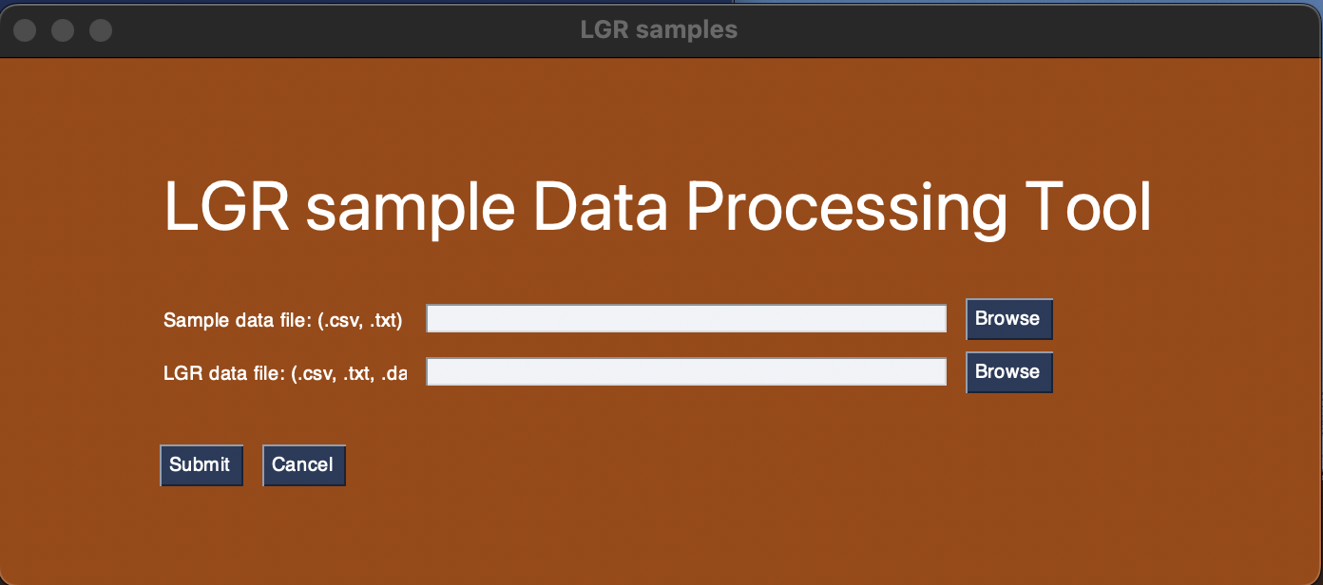

## required files

### Sample data file **(.csv or .txt)**

The sample data file is created by you! This file records the injection times for each sample or standard into the LICOR, these times are displayed on the LICOR as you run samples. This file is formatted by having one line per sample/standard that includes the samples name followed by a comma and followed again by the injection time. There’s an example file in the ‘*Sample-files’* folder in the ‘*PEDRO data analysis tool’* folder on the Wetland Soils and GHG Exchange Lab Microsoft Teams. An example of formatting is shown below.

### LGR file **(.csv or .txt)**

The other required file is the LGR data file obtained from the LGR gas analyzer itself. Don’t make any changes to the LGR data file.

## methodology

The methodology of this tool is identical to that of the LICOR sample tool. Refer to that section of the manual for more details.

## output

The output of this tool is identical to that of the LICOR sample tool. Refer to that section of the manual for more details.

# IRGA (EGM-5 only)

The IRGA (EGM-5) package analyzes the output from a EGM-5 gas analyzer and uses information passed through a field file to calculate gas fluxes.

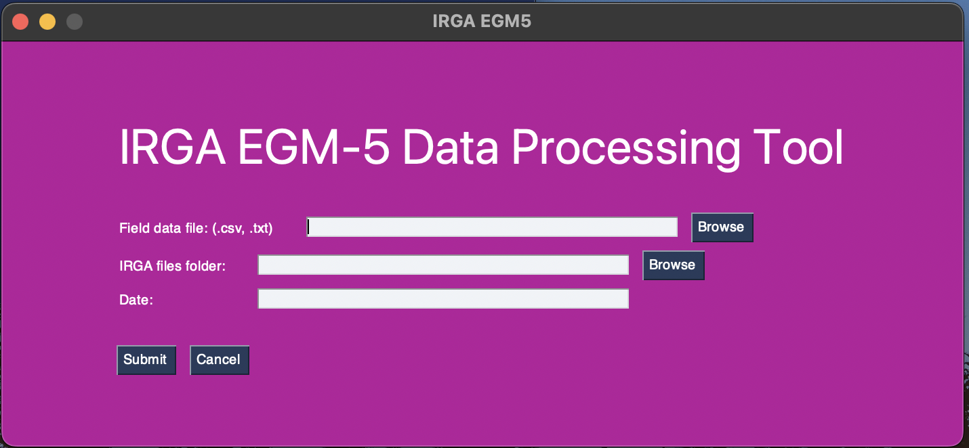

## required files

### Field data file **(.csv or .txt)**

The field data file is created by you! It’s a file that records information about each flux collar. Contrary to the LICOR and IRGA flux tools, the only information required in the EGM-5 field file is each flux’s collar name, collar surface area and chamber height. This is because the EGM-5 generates an individual file for each flux containing all gas, temperature, and PAR information. A template file can be found in the ‘*Sample-files’* folder in the ‘*PEDRO data analysis tool’* folder on the Wetlands Soils and GHG Exchange Lab Microsoft Teams.

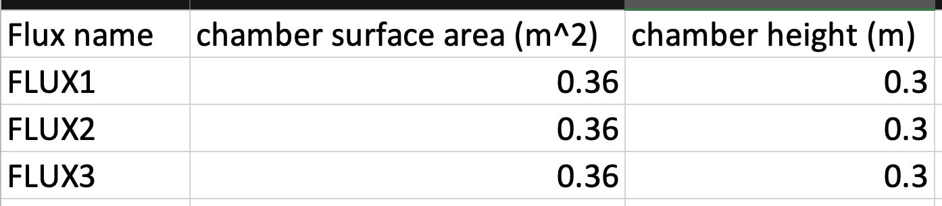

### Flux files **(.txt)**

These files must be obtained from the EGM-5 in the field and cannot be retrieved afterwards. On the back of the EGM-5, there’s a USB port for inserting memory which the EGM-5 uses to record data. Whenever a USB key is inserted, a new file is generated and when the key is removed, the file is terminated. In order to generate an individual file for each flux, plug in a USB key immediately before starting the flux and unplug it immediately after the flux is finished. Separately record the names of each flux’s collar in the order they’re completed. The EGM-5 names these files following an incrementing order naming convention, with the date the files is created followed by the order in which it’s generated. For example, the following files were all created on the 28th of July, 2022:

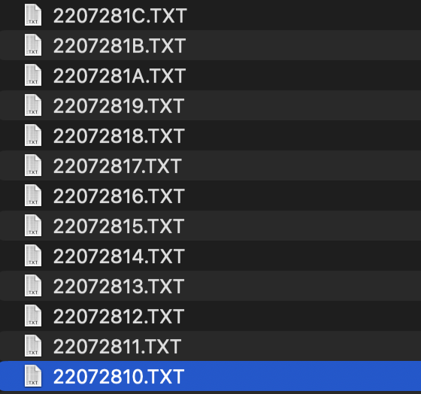

After retrieving all the flux files from the USB key, used the recorded order of collar names and the order of the files and rename each file to the name of its corresponding collar. The names of the files must match the names in the field file. Once the files have all been renamed, move them to their own separate folder. This folder should only contain these flux files.

## methodology

Instead of selecting an individual data file like when using the LICOR and LGR flux tools, when using the EGM-5 tool, you select the entire folder containing all the flux files. Once the field file and folder have been specified, this tool’s methodology is identical to that of the LICOR flux tool. Refer to that section of the manual for more details.

## output

The output of this tool is identical to that of the LICOR flux tool. Refer to that section of the manual for more details.

# GC

The GC package allows for quickly extracting gas data from the reports outputted by the GC and LabSolutions software and compiling it into a spreadsheet.

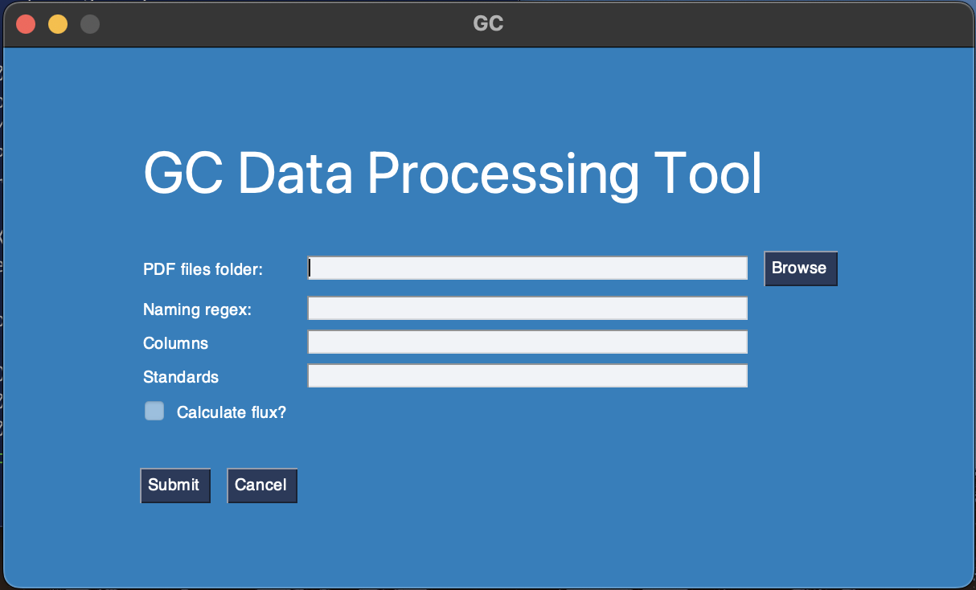

## required files

The only required files are the outputted reports from the GC in .pdf format. These PDFs can be obtained from the lab computer and downloaded onto a USB with the following steps.

1. After a batch file has been run, double click the file to open *Postrun Analysis* in the LabSolution software

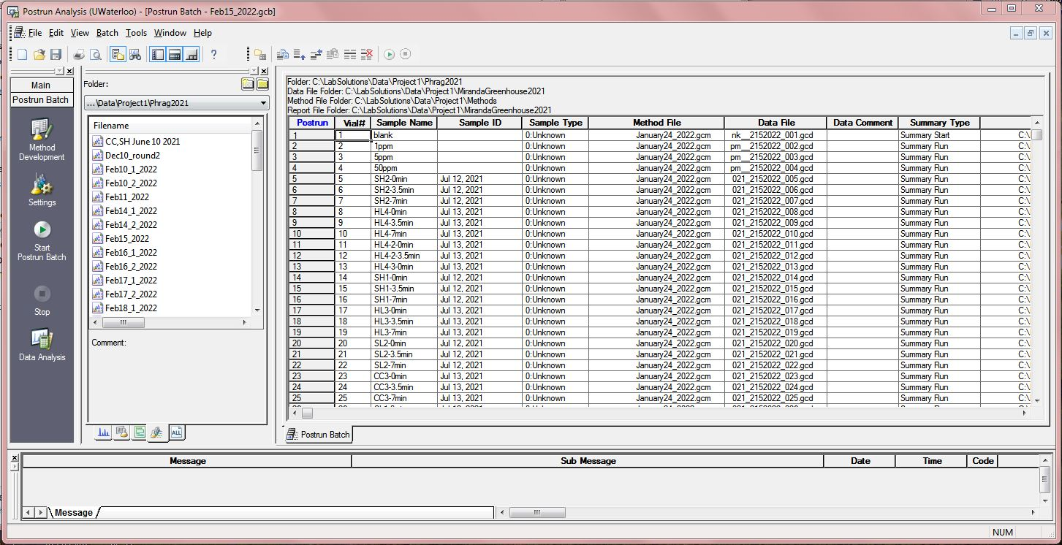

1. In the *Postrun Analysis* windowselect *File > Print Setup*
2. In the *Print Setup* window, Change the print destination to *Foxit PhantomPDF Printer* and select *OK.*

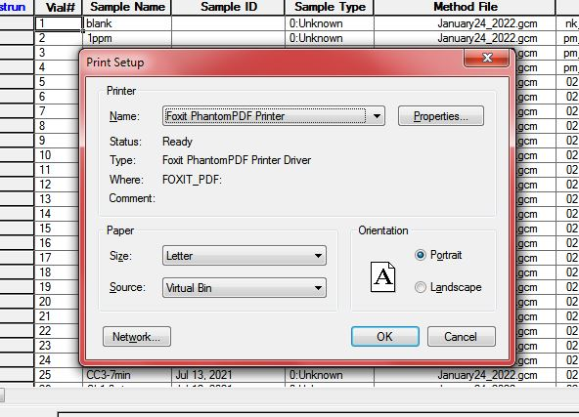

1. Back in the *Postrun Analysis* window, select *Start Postrun Batch*.
2. Once LabSolutions has finished analysing the data, you’ll be prompted to select a location and name for the output PDF file.

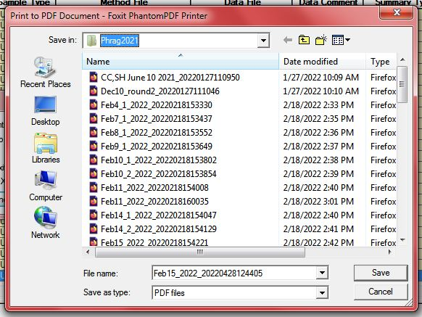

1. Once you’ve retrieved all the PDFs for your samples, store them all in the **same folder** on your computer.

## naming regex

In order to make the GC tool as universal as possible, you’ll have to provide information on how your samples were named, this information is given in the ‘*Naming regex’* field in the form. This regex is a single line formula that indicates how you’ve named your samples. There are five different options used to build the regex:

* *S*, represents a value that can only be made up of letters
* *D*, represents a value that can only be made up of numbers
* *X*, represents a value that can be made up of a combination of letters and numbers
* *-*, represents a delimiter, includes any of the following: ‘-‘, ‘ ‘, ‘_’
* *()*, surrounds a value that will be represented as a distinct column

**Important: Do not include the sample date in the sample name, in the template batch file on the lab computers, there’s a column called ‘*Sample ID’*, use this column for the sample’s date.**

### Examples

* Samples named as *‘transect-time(minutes)’*
  + Eg. *‘HH8-3.5min’, ‘SL7-0min’, ‘HL4-7min’*
  + We want to track *Transect* and *Time* in their own columns.
  + Naming regex: (X)-(D)S
  + Explanation:
    - Transects will be represented in a column and contain both letters and numbers, so it’s represented as (X).
    - There’s a dash delimiter between the transect name and the time, so there’s a ‘-‘ between the (X) and (D).
    - The time of each sample will be represented in a column, and we’re only interested in the number, so it’s represented as (D).
    - After each time measurement there’s a unit ‘min’ which we’re not concerned with representing in a column, so it’s represented as S, with no brackets immediately following the (D) since there’s no delimiter separating the two.
* Samples named as ‘*Site-temperature(C)-time(minutes)*
  + Eg. *‘Burned-15.7C-3.5min’, ‘Natural-17.8C-7min’, Burned-20.2C-0min’*
  + We want to track *Site, Temperature* and *Time* in their own columns.
  + Naming regex: (S)-(D)S-(D)S
  + Explanation:
    - Sites will be represented in a column and they’re only letters, so it’s represented as (S).
    - There’s a dash between site and temperature, so there’s a ‘-‘ between (S) and (D)
    - Temperatures will be represented in a column, and they contain only numbers, so it’s represented as (D)
    - The unit ‘*C’* should not be included in the temperature column, and it contains only letters, so it’s represented as S immediately after the (D)
    - Times will be represented in a column, and they contain only numbers, so it’s represented as (D)
    - The unit ‘min’ should not be included in the time column, and it contains only letters, so it’s represented as S immediately after the (D)

## methodology

Once you’ve entered the folder where the PDfs are stored as well as the determined naming regex for your samples, you must enter the names of each column you’d like to be distinct. **The number of columns should match the total number of () units in your naming regex.** As well, you must include the distinct standards used in the batches with your samples. An example of a properly filled GC form is shown below.

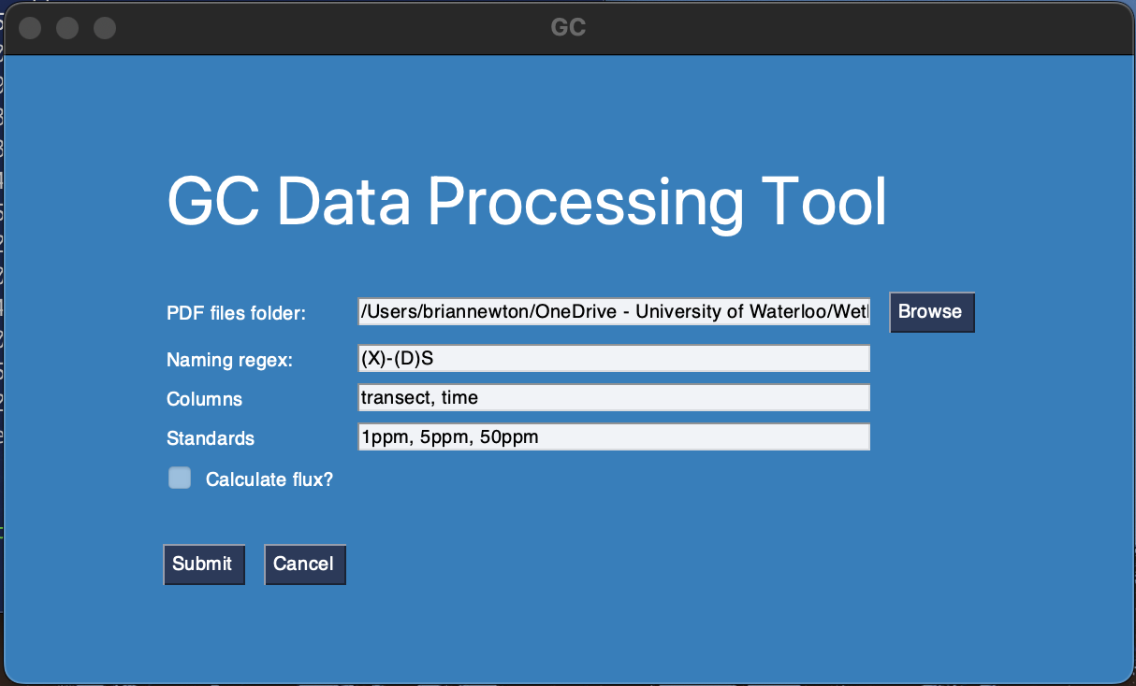

You can also choose to calculate flux data by ticking the ‘*Calculate flux’* box. However, if using this option specific criteria must be met. The last column ‘()’ in your naming regex must be the time your samples were taken in minutes and there must be multiple times taken for each unique combination of every other column. Examples of this are shown below.

* Can be used with flux:
  + HH8-0min, HH8-3.5min, HH8-7min
  + Burned-B2-0min, Burned-B2-3min, Burned-B2-6min, Burned-B2-10min
* Cannot be used with flux:
  + HH8-0min-H5, HH8-3.5min-H5, HH8-7min-H5
  + Burned-B2-Fen, Burned-B3-Fen, Burned-B4-Fen

**This cannot change, please keep this in mind when entering sample names while creating your batch files. If your batch files have already been created and ran, you’ll have to use the tool without flux calculation and do the calculations by hand.**

After entering in all relevant information, click on *Submit* and the tool will start processing the PDFs stored in the indicated folder. Depending on the number of samples, this could take several minutes. A progress bar will appear.

## output

Once the tool has finished analyzing each PDF in the indicated folder, it will prompt you to select a name and location for the output excel spreadsheet.

### Standards sheet

The first sheet in the results excel file will contain all the standards that were present in the batch file PDFs. For each standard, it will report the methane concentration, carbon dioxide concentration, oxygen and nitrogen percentage and nitrous oxide concentration. It will also indicate which PDF file any given standard was pulled from. An example of the standards sheet is shown below.

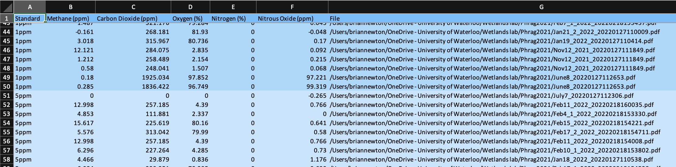

### Date sheets

The tool will also generate a separate sheet for each unique sample date, recorded in the ‘*Sample ID’* column. These sheets will display any samples that were taken on that given date. These sheets will report all the same data as the standard sheet.

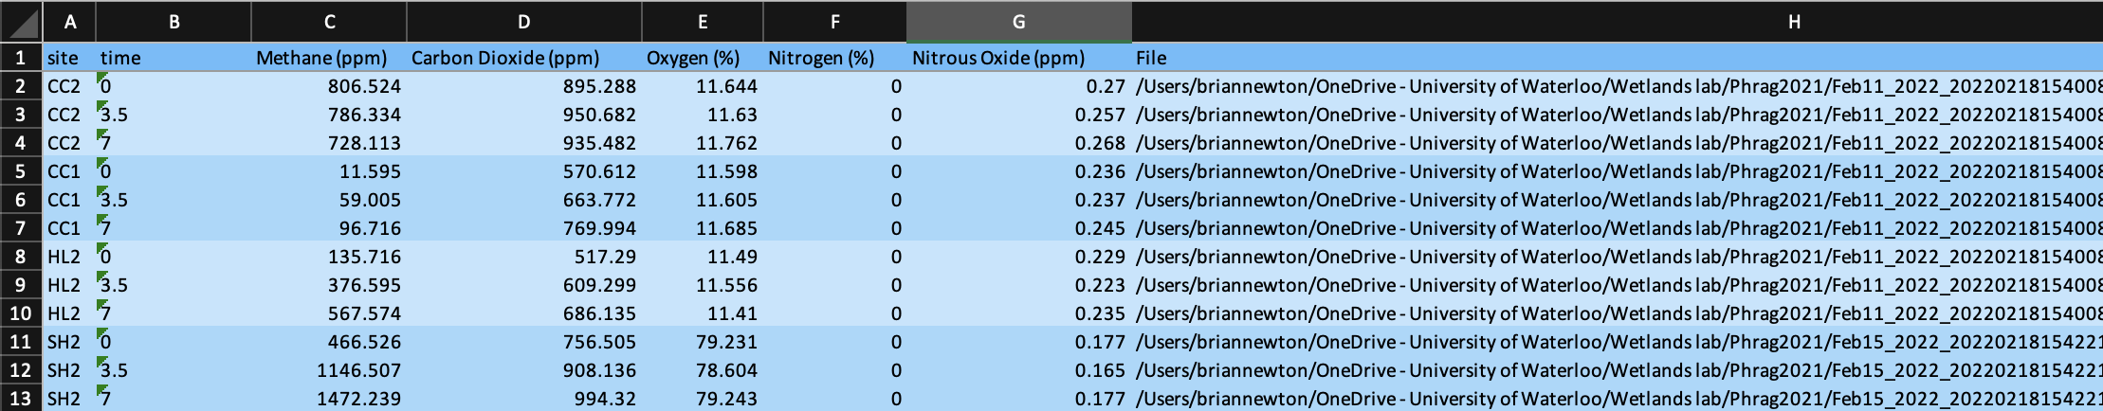

If you chose to calculate flux data, additional rows will be generated showing calculated rate of change and R2. You must fill in the volume, temperature and chamber dimension information for the full flux value.

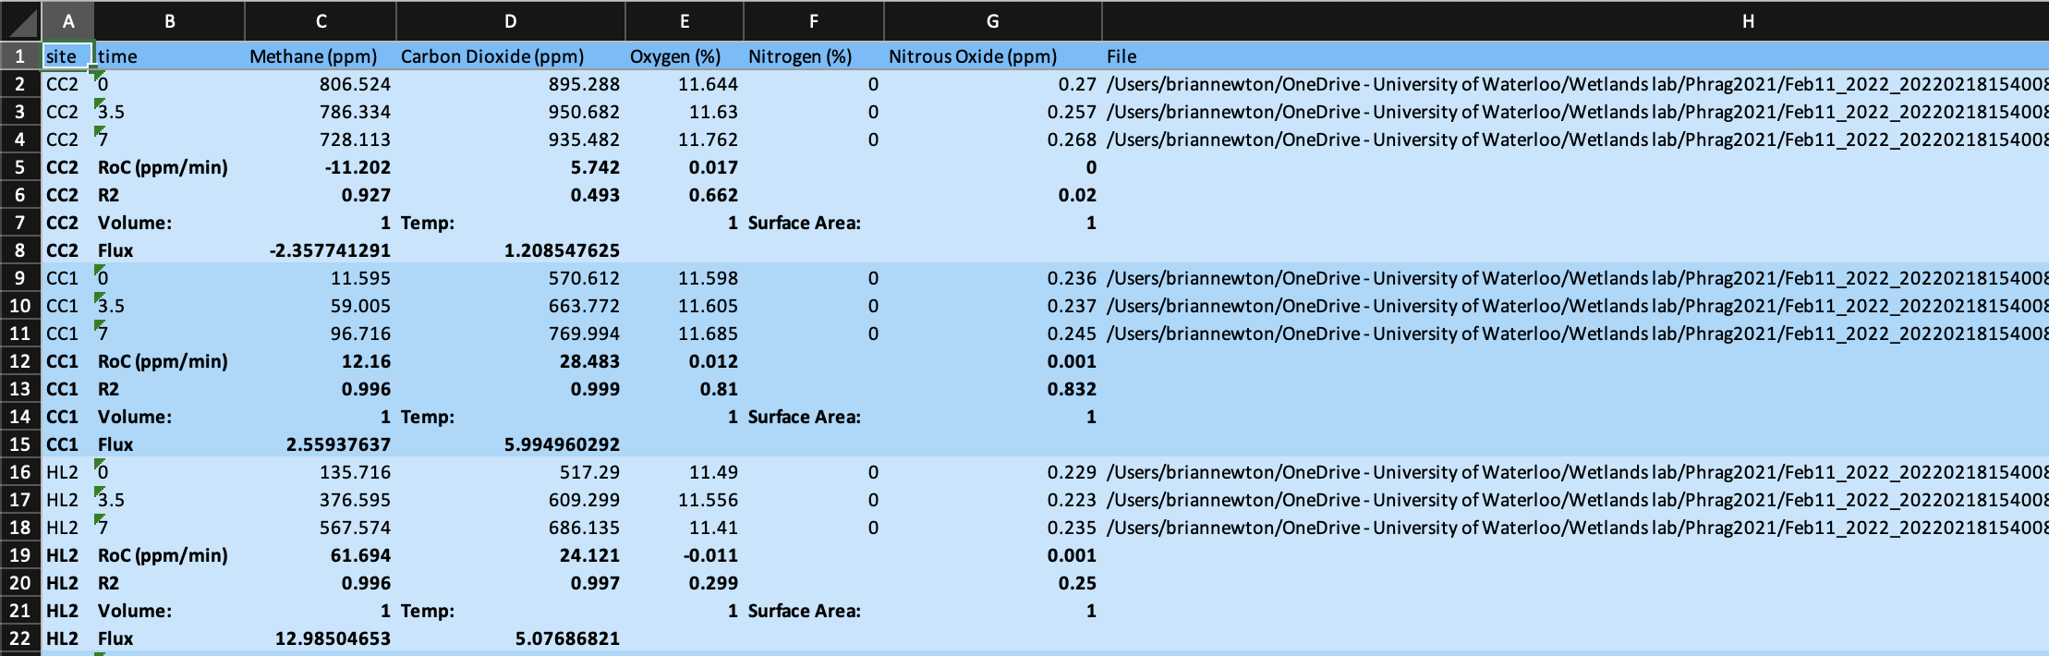

# Source code

If you’d like to view the source code, it can be found in this [GitHub repository](https://github.com/BrianNewton/PEDRO). If you’d like to make any changes, feel free to send a pull request and it will be reviewed before being merged.

# Support

For any questions, comments or concerns, email [btnewton@uwaterloo.ca](mailto:btnewton@uwaterloo.ca) for support. If this email is no longer active, please contact [briannewton2000@gmail.com](mailto:briannewton2000@gmail.com).

# Acknowledgements

Thanks to Dr. Maria Strack, Kim Kleinke, Miranda Hunter, Meg Schmidt and Abi Shingler from the Wetland soils and greenhouse gas exchange lab, the making of this tool would not have been possible if not for their insight and feedback.